Project: Info Extractor

# Table of contents

Introduction 3

Methodologies 4 - 7

References 8

Introduction

This is a project about extracting information from the system using a bash script. The bash script is meant to be beginner-friendly, requiring the user to just run the script, without any further user inputs. The commands used in the script cover the modules that the students of CFC130124 went through, applying what they’ve learned, and reinforcing their knowledge of how the lessons might be applied in a real-world scenario. The following pages will describe the way how each part of the information is obtained from the system. An example of the results from the script:

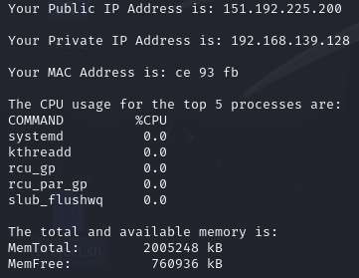

Methodologies

The first part of the script requires the extraction of the machine’s Public IP Address.

 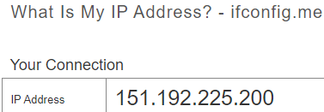

The command curl is a tool for transferring data from or to a server using URLs. The Public IP Address is directly imported from the website <https://ifconfig.me/>.

The second part of the script extracts the machine’s Private Address.

The command ifconfig brings up the IP configurations of the machine.

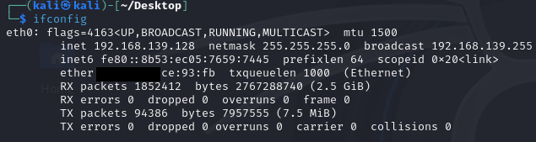

But as the command brings up a whole lot of other information. grep is used to streamline the provided information (in this case broadcast), limiting it to only line 2 being displayed. With awk ‘{print $2}’, only the second column will be printed, further streamlining it down.

The third part of the script extracts the machine’s MAC address.



This time, ether is being grep so that only information from that line is displayed.



Again, with awk ‘{print $2}’, only the second column will be printed. However, due to security reasons, only the second set of the MAC address will be shown. This can be done by further streamlining the information shown. Using awk -F: ‘{print $4,$5,$6}’, columns 4,5 and 6 will be printed, using ‘:’ as the separator instead.

Part four of the script extracts the top 5 processes utilizing the CPU.

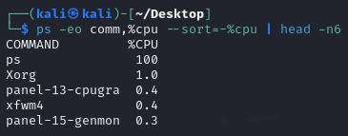

The command ps displays information about a selection of the active processes. The -eo flag will display everything in the format given, in this case, comm,%cpu. This will bring up the command and the percentage of the CPU the said command is utilizing. Results are sorted by the percentage in descending order using –sort=-%cpu, top 6 lines will be displayed using head -n6 with line one being the ‘title’.

Part five of the script extracts the total and available memory of the machine.

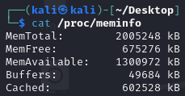 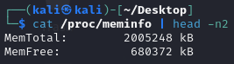

/proc/meminfo provides a usage report about memory on the system. Since only total and available memory are required to be displayed. head -n2 is used to limit the information.

Part six of the script extracts the active system services and their status.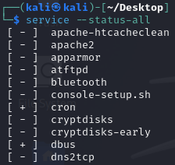

This topic was specifically covered during the Network Services lesson. It is time to put it into practice. The command service –status-all brings up all the services installed on the machine and their status, with [ + ] denoting that they are running.

The last part of the script extracts the top 10 largest files in the machine’s /home directory.

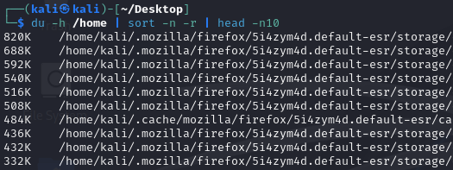

The du command estimates file space usage. The -h flag will render the information in human-readable format, in this case, Kilobytes. Sorting it using sort -n -r presents the data in descending order, starting from the largest. Lastly, using head -n10 will display the top 10 lines. This concludes the script.

References

ifconfig.me. (n.d.). *What Is My IP Address? - ifconfig.me*. [online] Available at: <https://ifconfig.me/>.

Jethva, H. (2022). *How to Find the Top Memory Consuming Processes in Linux*. [online] Atlantic.net. Available at: <https://www.atlantic.net/vps-hosting/find-top-10-running-processes-by-memory-and-cpu-usage/>.

Jethva, H. (2021). *How to Check Size of Files and Directory on Linux*. [online] Atlantic.net. Available at: https://www.atlantic.net/vps-hosting/how-to-check-size-of-files-and-directory-on-linux/ [Accessed 8 Feb. 2024].

Contributor, I.H. (2014). *How to Check the Memory Usage on Linux*. [online] InMotion Hosting Support Center. Available at: https://www.inmotionhosting.com/support/server/linux/check-memory-usage/#:~:text=The%20most%20common%20way%20you [Accessed 8 Feb. 2024].

MyBib Contributors (2019). *Harvard Referencing Generator – FREE – (updated for 2019)*. [online] MyBib. Available at: <https://www.mybib.com/tools/harvard-referencing-generator>.